**ÔN TẬP UNIT 7**

**I. Find the word which has a different sound in the part underlined.**

1. A. tr**a**ffic        B. p**a**vement          C. pl**a**ne          D. st**a**tion

2. A. r**e**cycle       B. v**e**hicle            C. h**e**licopter       D. r**e**verse

3. A. r**ai**lway       B. m**ai**l              C. s**ai**l           D. capt**ai**n

4. A. s**i**gn         B. m**i**stake           C. tr**i**angle         D. dr**i**ve

5. A. n**ea**rest       B. h**ea**d             C. br**ea**d          D. h**ea**lth

**II. Find the odd once out A, B, C or D.**

1. A. riding         B. driving            C. gardening       D. flying

2. A. no cycling     B. no parking         C. no right turn      D. sign

3. A. train          B. plane             C. car            D. sail

4. A. by car        B. on foot            C. by bus         D. by bicycle

5. A. rule          B. ride              C. reverse         D. drive

**III. Choose the best option A, B, C or D to complete the sentence.**

1. Minh used to......................his homework late in the evening.

A. does           B. do               C. doing           D. did

2. If people.....................the rules, there are no more accidents.

A. follow          B. take care of        C. obey           D. remember

3. You should..................right and left when you go across the roads.

A. see            B. look              C. be             D. take

4. Hurry up or we can't...................the last bus home.

A. keep           B. follow             C. go             D. catch

5. Lan used to go to school...............

A. with bicycle      B. by foot            C. in car           D. by bus

6. Public..................in my town is good and cheap.

A. transport        B. tour              C. journey          D. travel

7. ..................is not very far from here to the city centre.

A. That           B. This              C. It              D. There

8. When there is a traffic jam, it.....................me a very long time to go home.

A. costs           B. takes             C. lasts            D. spends

9. Mai's dad usually drives her to school................her school is very far from her house.

A. but             B. though            C. because         D. or

10. Yesterday Hoa and Lan......................round West Lake. It took them an hour.

A. cycle           B. cycles            C. cycling          D. cycled

**IV. Fill each blank with a word given in the box:**

|  |
| --- |
| vehicles    across      did       ride      feels  break      it      rules      accidents       after |

1. What.......................you do last Sunday?

2. I stayed at home and looked.....................my younger brother yesterday.

3. Does your bike ever..................down on the way to school?

4. We must always obey traffic.......................for our safety.

5. How far is.................from your house to the bus stop?

6. He used to.....................a tricycle when he was three years old.

7. Now there are more traffic....................than there used to be in this city.

8. There did not use to be many...................on the roads in my home town.

9. He lives in a small village in the mountains so he never........................worried about traffic jams.

10. You should remember to walk.......................the streets at the zebra crossings.

**V. Rewrite the following sentences so that their meaning stays the same, using the words give.**

1. The distance from my house to school is about 500 metres. (It)

......................................................................................................................

2. My father went to work by car some years ago, but now he goes by bus. (used to)

......................................................................................................................

3. Don't drive too fast or you'll have an accident. (If)

......................................................................................................................

4. Is it possible to go to Sa Pa by motorbike? (Can)

......................................................................................................................

5. My mother is a careful driver. (drives)

......................................................................................................................

6. He had a stomachache. He didn't wash his hands. (so)

................................................................................................

**VI. Read the passage and choose the best answer:**

Yesterday, on the way home from school, I saw an accident. A boy was run over by a taxi when he was riding his bicycle. The boy's leg was broken and it was bleeding badly. Someone there tried to stop the bleeding. They put pressure on it and held it tight. A man used his mobile phone to call the emergency service. Some minutes later, an ambulance arrived and sent the boy to the hospital. Two policemen came to the scene immediately. Some people told the police that the taxi was driving at a very high speed when the accident happened. Some others began talking about the traffic accidents these days and blamed the increasing number of accidents on the roads for careless driving and drunk drivers.

1. What did the writer see yesterday?

A. a fire         B. an accident            C. a fighting          D. a crash

2. The accident happened between a taxi and................

A. a bus        B. a car                 C. a bicycle          D. a motorbike

3. The boy was sent to the hospital by................

A. a police       B. a car                 C. an ambulance       D. a passenger

4. What part of his body was hurt? – His....................

A. arm          B. leg                  C. head             D. shoulder

5. How was the driver driving when the accident happened? – Very................

A. slowly        B. fast                 C. carefully           D. well

**VII. Choose the word (a, b, c, or d) that best fits each of the blank spaces.**

This composition is about my aunt's (1)......... in Florida last year.

She hired a car at Miami (2)........ , and soon (3)..........lost. So, she stopped to ask a young man how to get to the hotel.

Unfortunately, the young man had a gun; he made my aunt get (4)............ of the car, and she had to give him all her money.

Luckily, a police car drove past a few minutes later and (5).......... . Then, the police arrested the thief and got my aunt's money back.

(6)........ the end, my aunt had quite a good holiday, but she said that she was happy to get back home.

1. a. holiday         b. vacation           c. festival               d. a & b

2. a. airport          b. airway             c. airplane               d. airstrip

3. a. took           b. had               c. got                  d. caught

4. a. in             b. out               c. inside                d. outside

5. a. picked her up     b. picked up her       c. showed her around       d. showed around her

6. a. In             b. At               c. On                  d. When

**VIII. Make up sentences using the words and phrases given:**

1. We/ used/ school/ on/ foot.

......................................................................................................................

2. about / 30km/ my town/ Ha Long Bay/.

......................................................................................................................

3. My family/ used/ go / holiday / seaside / summer/.

......................................................................................................................

4. How/ long / it / take/ you/ Ha Noi / Sa Pa/?

......................................................................................................................

5. There / used / be / a factory / town centre / but/ it / move/ the/ suburbs/.

......................................................................................................................

6. You/ must / learn / about / road safety/ before/ riding/ your/ bike/ road/.

......................................................................................................................

**ÔN TẬP UNIT 8**

**\*\*\* ALTHOUGH, THOUGH, EVEN THOUGH, DESPITE, IN SPITE OF**

Các liên từ này đều có nghĩa là “***mặc dù***”, tuy nhiên lại khác nhau về ngữ pháp. Để tiện cho việc ghi nhớ và học tập, chúng ta sẽ chia chúng thành 2 nhóm:

* ***Nhóm 1: Although, Though, Even though***
* ***Nhóm 2: Despite và In Spite of.***

***\*Nhóm 1: Although, Though, Even though***

Theo sau là 1 mệnh đề có chủ ngữ và động từ

**Although/ though/ even though + S + V (chia theo thì thích hợp)**

Ví dụ:

*She walked home by herself although she knew that it was dangerous.*

### Có thể đứng ở đầu câu hoặc giữa hai mệnh đề

### Chú ý

➤ Khi đảo Although/ Though/ Even though lên đứng đầu câu, ta phải sử dụng dấu phẩy sau mệnh đề chính. Ngược lại nếu đứng ở giữa câu thì không cần dấu phẩy.

* ***Nhóm 2: Despite và In Spite of.***

### Theo sau là danh từ, cụm danh từ hoặc danh động từ (V-ing)

**Despite/ In spite of + N/ phrase/ V-ing**

Ví dụ:

The game continued despite the rain.

In spite of her illness, she came to work

Giống với Though/ Although/ Even though, Despite và In spite of đều có thể đứng đầu câu hoặc giữa hai mệnh đề.

### Có thể đi với “the fact that”

Khi muốn viết lại câu từ nhóm 1 sang nhóm 2, chúng ta chỉ việc thêm cụm từ “the fact that” vào phía sau Despite hoặc In spite of.

**Despite/ In spite of the fact that + S + V (chia theo thì thích hợp)**

Ví dụ:

In spite of her illness, she came to work

= In spite of the fact that she was ill, she came to work

## **Bài tập vận dụng**

Chọn một trong các từ thích hợp sau để điền vào chỗ trống: ***although, in spite of, because, because of***

1. ________________ she is beautiful, everybody hates her.
2. The children slept deeply ________________ the noise.
3. ________________ earning a low salary, Sara helped her parents
4. Jane rarely sees Alan ________________ they are neighbors.
5. Kate did not do well in the exam ________________ working very hard.
6. ________________ I was very hungry, I couldn’t eat.
7. ________________ the difficulty, they managed to solve the math problem.
8. Liza never talked to him ________________ she loved him.
9. ________________ it was cold, Marie didn’t put on her coat.
10. Clare did the work ________________ being ill.
11. ________________ the weather was bad, we had a good time.
12. ________________ all our hard work, a lot of things went wrong.
13. ________________ we had planned everything carefully, a lot of things went wrong.
14. I went to hospital ________________ I was feeling very ill.
15. I went to work the next day ________________ I was still feeling ill.
16. She accepted the job ________________ the low salary.
17. She refused the job ________________ the low salary.
18. I managed to sleep ________________ the hotel was noisy.
19. I could not get to sleep ________________ the noise.
20. He runs fast ________________ his old age

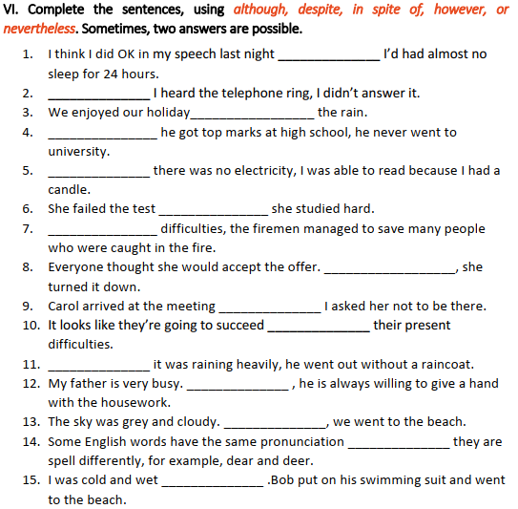

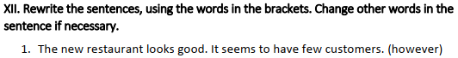**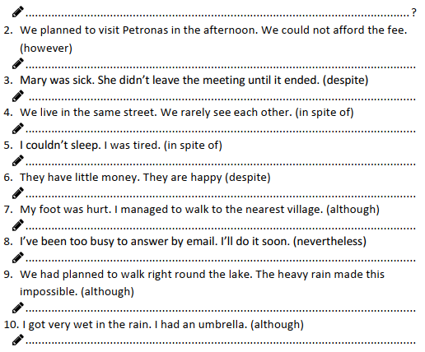---------------**

**Question I. Find the word which has different sound in the part underlined.**

1. A. want**ed**          B. wash**ed**       C. work**ed**        D. stopp**ed**

2. A. cycl**ed** B. stay**ed**        C. decid**ed** D. play**ed**

3. A. **wh**o             B. **wh**en         C. **wh**ere         D. **wh**at

4. A. watch**ed**         B. danc**ed**        C. walk**ed**       D. bor**ed**

5. A. need**ed**B. decid**ed**        C. play**ed**       D. want**ed**

6. A. provid**ed**B. start**ed**        C. work**ed**D. decid**ed**

7. A. clos**ed**           B. play**ed** C. stopp**ed**      D. stay**ed**

8. A. **wh**ole           B. **wh**y           C. **wh**at         D. **wh**en

9. A. call**ed**           B. wait**ed**C. play**ed**       D. lov**ed**

10. A. look**ed**B. liv**ed**          C. laugh**ed** D. watch**ed**

11. A. start**ed**         B. decid**ed**        C. work**ed**        D. wait**ed**

12. A. play**ed**         B. stopp**ed**       C. watch**ed** D. lik**ed**

13. A. **wh**om          B. **wh**en          C. **wh**ere         D. **wh**at

14. A. watch**ed**        B. miss**ed**        C. walk**ed**D. play**ed**

15. A. collect**ed**B. decid**ed** C. play**ed**        D. want**ed**

16. A. nak**ed**         B. watch**ed**       C. work**ed**       D. stopp**ed**

17. A. liv**ed**           B. play**ed**        C. stay**ed**        D. dogg**ed**

18. A. look**ed**         B. work**ed**         C. nak**ed**       D. lik**ed**

19. A. want**ed**        B. wait**ed**          C. play**ed**        D. belov**ed**

20. A. miss**ed**B. stopp**ed**       C. want**ed**        D. watch**ed**

**Question II. Choose the correct adjectives.**

1. Are you **(interesting/ interested)** in football?

2. The football match was quite **(exciting/ excited).**I enjoyed it.

3. It’s sometimes **(embarrassing/ embarrassed)**when you have to ask people for money

4. Do you usually get **(embarrassing/ embarrassed)?**

5. I had never expected to get the job. I was really **(amazing/ amazed)**when I was offer it.

6. She has really very fast. She has made **(astonishing/ astonished)**progress

7. I didn’t find the situation funny. I was not **(amusing/ amused)**

8. It was a really **(terrifying/ terrified).**Afterwards everybody was very **(shocking/ shocked)**

9. Why do you always look so **(boring/ bored)?**Is your life really so (boring/ bored)?

10. He’s one of the most **(boring/ bored)**people I’ve ever met. He never stops talking and he never say anything **(interesting/ interested**).

11. At first I thought Jake was an **interesting/ interested** guy, but tonight I felt somewhat **boring/ bored** with his company.

12. She has really learnt very fast. She has made **astonishing/ astonished**

13. It was very **disappointing/ disappointed** not to get the job.

14. Philip was exceptionally **annoying/ annoyed** at Joanne's behaviour.

15. I thought the program on wildlife was **fascinating/ fascinated**. I was absolutely **fascinating/ fascinated.**

16. We were **thrilling/ thrilled**to hear your good news.

17. It was really **terrifying/ terrified.**Afterwards, everybody was very **shocking/ shocked.**

18. The journey took all day and night. They found it very **tiring/ tired.**

19. Did Tim feel **frightening/ frightened**when he saw the snake at his feet?

20. Why do you always look so **boring/ bored.**Is your life really

**Question III. Complete the sentences with present participle or past participle form of the verb in brackets.**

1. The film wasn't as good as we had expected. (disappoint)

a. The film was _________________________ .

b. We were ________________________ with the film.

2. Diana teaches young children. It's a very hard job but she enjoys it.(exhaust)

a. She enjoys her job but it is often ______________________ .

b. At the end of a day's work, she is often _______________________ .

3. It's been raining all day. I hate this weather. (depress)

a. This weather is _____________________ .

b. This weather makes me ______________________ .

c. It's silly to get ____________________ because of the weather.

4. Clare is going to the United States next month. She has never been there before. (excite)

a. It will be an ________________ experience for her.

b. Going to new places is always ________________ .

c. She is really __________________ about going to the United States .

**Question IV. Choose the correct answer.**

1. I always feel …………… before examinations. (nervous/ nervously)

2. He speaks English …………… (fluent/ fluently)

3. It is an ………… book. (interesting/ interestingly)

4. He drove …………… and he had an accident (careless/ carelessly)

5. We didn’t go out because it was raining …………… (heavy/ heavily)

6. The football match was very ……………… I enjoyed it. (exciting/ excitingly)

7. She tried on the dress and it fitted her …………… (good/ well)

8. He never has accidents because he always drives …………… (careful/ carefully)

9. He behaved ……………… towards his children. (strict/ strictly)

10. It’s too dark to see ……………… (clear/ clearly)

**Question V: Complete the sentences with although/ in spite of/ because/ because of**

1. **Although** it rained a lot, we enjoyed our holiday.

2. a, ……………………..... all our careful plans, a lot of things went wrong.

b, ………………... we'd phoned everything carefully, a lot of things went wrong.

3. a, I went home early ……………….……... I was feeling unwell.

b, I went to work the next day………………… .... I was still feeling unwell.

4. a, She only accepted the job ....................................... the salary, which was very high.

b, She accepted the job ……………………………….. the salary, which was rather low.

5. a, I managed to get to sleep ………………………... there was a lot of noise.

b, I couldn't get to sleep ………………………………...... the noise.

**Question VI: Make one sentence from two. Use the word(s) in brackets in your sentences.**

1. I couldn't sleep. I was very tired.

Despite I couldn't sleep despite being vey tired.

2. They have very little money. They are happy.

In spite of .......................................................................................................................................

3. My foot was injured. I managed to walk to the nearest village.

Although ........................................................................................................................................

4. I enjoyed the film. The story was silly.

In spite of .......................................................................................................................................

5. We live in the same street. We hardly ever see each other.

Despite ..........................................................................................................................................

6. I got very wet in the rain. I was only out for five minutes.

Even though ..................................................................................................................................

**Question VII. Rewrite sentences with In spite of / Despite /because / because of**

1. Although Tom was a poor student, he studied very well.

In spite of _______________________________________________________________

2. Mary could not go to school because she was sick.

Because of ____________________________________________________________

3. Although the weather was bad, she went to school on time.

Despite ______________________________________________________________

4. Because there was a big storm, I stayed at home.

Because of ____________________________________________________________

5. In spite of his good salary, Tom gave up his job.

Although ___________________________________________________________

6. He is so young. His acting is excellent.

Although_____________________________________________________________

7. The film poster is fascinating. I don't want to see this film.

In spite of___________________________________________________________________

8. Although our plan is careful, we made some mistakes.

Despite_______________________________________________________________