EXERCISES FOR GRADE 7 – UNIT 7
B. VOCABULARY - TỪ VỰNG
Từ mới | Phiên âm | Nghĩa
cross | /krɒs/ | băng qua, vượt
curve | /kəːv/ | khúc cua
emergency | /iˈməːdʒ(ə)nsi/ | khẩn cấp
hill | /hɪl/ | đồi
lane | /leɪn/ | làn đường
left | /lɛft/ | trái
limit | /ˈlɪmɪt/ | giới hạn
pedestrian | /pəˈdestriən/ | người đi bộ
railroad | /ˈreɪlrəʊd/ | đường ray
right | /raɪt/ | phải
sign | /saɪn/ | biển hiệu
slippery | /ˈslɪp(ə)ri/ | trơn trượt
speed | /spiːd/ | tốc độ
traffic lights | /ˈtræfɪk laɪts/ | đèn giao thông
truck | /trʌk/ | xe tải
turn | /təːn/ | rẽ
vehicle | /ˈviː(ə)kl/ | phượng tiện
wet | /wɛt/ | ẩm, ướt

C. EXERCISES - BÀI TẬP THỰC HÀNH
PART 1. PHONETICS
1. Find the word which has a different sound in the part underlined. Read the words aloud.
1. A. wet B. met C. head D. hand
2. A. girl B. burn C. turn D. pearl
3. A. left B. debt C. fan D. dead
4. A. train B. tale C. mine D. rain
5. A. die B. bicycle C. high D. min
6. A. meet B. feed C. speed D. fit
7. A. limit B. lipid C. treat D. hit
8. A. curve B. term C. gear D. herm
9. A. truck B. drunk C. mug D. dark
10. A. sign B. light C. bye D. tin
2. Put the words with the underlined part in the box into two groups.
train young helicopter left
video plane rain tour
railway late southern does
station dead grey shoulder
head no wet road
/eɪ/ | /ɛ/

3. Label the signs with the words/phrases below.
Danger Railroad Crossing Right Lane Ends
No Trucks Right Turn Ahead
Right Curve Ahead Watch Children
Emergency Vehicle Warning No Pedestrian Crossing

a. | e.  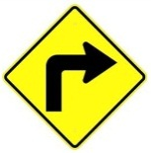
b.  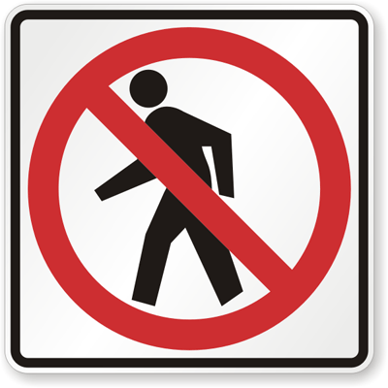 | f.  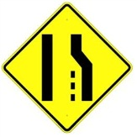
c.  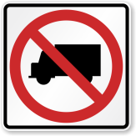 | g.  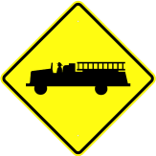
d.  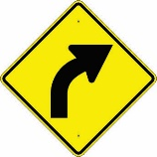 | h.  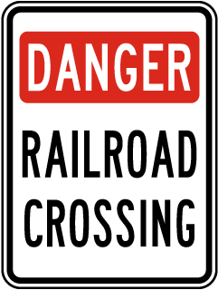
PART 2: VOCABULARY & GRAMMAR
1. Circle A, B, C or D for each picture.
1.  A. Maximum speed is 5.  B. Minimum speed is 5.  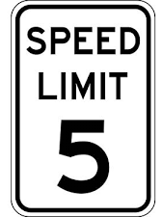  C. Only 5 MPH is allowed.  D. Speed limit is lower than 25 MPH. | 4.  A. You can buy cattle meat here.  B. There are cattle ahead.  C. There are wild animals ahead.  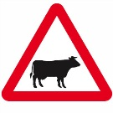  D. Cattle are not allowed.
2.  A. Cars cannot be sold here.  B. Cars and trucks can pass.  C. Cars are not allowed.  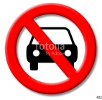  D. Bicycles are not allowed. | 5.  A. Bullying is allowed.  B. Bully may be arrested.  C. Bullying must be stopped.  D. This zone is dangerous.
3.  A. You cannot return.  B. Go ahead isn't allowed.  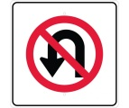  C. You must return.  D. Watch out the pedestrians. | 6.  A. Cameras are used here.  B. You can't use your camera here.  C. Cameras are sold ahead.  D. Take photograph when crossing road.
2. Find one odd word A, B, C or D.
1. A. train B. plane C. plant D. car
2. A. left B. right C. straight D. square
3. A. green B. red C. orange D. light
4. A. drive B. write C. ride D. fly
5. A. fast B. rapid C. slow D. quick
3. Put questions for the underlined parts in the following sentences, using question words in brackets.
1. Nam usually goes to school by bus. Sometimes, he rides his bicycle. (How)

2. My grandfather used to go fishing in the West Lake every afternoon. (What)

3. There are a lot of trucks and cars on the highway in the rush hour. (Where)

4. The students used to be taught about road signs when they studied in secondary school. (What)

5. Hung always drives his car very carefully. (How)

6. It is about 100 km from Ha Noi to Hai Phong. (How long)

4. Fill each blank with suitable words in the box.
am is are used to use to it from
to catches walked ride jam station
1. Mai driving her car to her office.
2. How far it from your home to your school?
3. You will get stuck in a traffic if you go outside in the rush hour?
4. He usually on foot to school when he was a child.
5. you in hurry?
6. Did you go swimming on the lake near your house, Tuan?
7. Lana comes USA. She was born in a well-known family.
8. My dad the bus to work every morning, but Mom drives.
9. John used to immigrate Brazil. Have you ever been there?
10. I participating in a volunteer trip to Lang Son. A lot of families are living in poor conditions.
11. is not very far from here to the warehouse.
12. I must go to railway to catch a train to my motherland.
5. Complete the following conversation with the sentences A-F.
Burt: Why didn't you show up for class this morning?
Kevin: I don't even want to talk about it. .
Burt: ?
Kevin: The engine seems to be busted. !
Burt: Wow. Have you thought about getting a new car?
Kevin: Yeah, I've thought about that, .
I'm broke.
Burt: Maybe you can lease a car. .
I know Toyota is running a promotion.
Kevin: Really? How much is it?
Burt : .
Kevin: That's a good deal. I might want to consider it.
A. My car broke down | D. It doesn't cost much
B. It's driving me crazy | E. but I can't afford a new car
C. Zero down and $219 per month | F. What happened

6. Give the correct form of the words in brackets.
Traffic jam (to be) a common sight in big cities like Delhi, Mumbai, Calcutta etc. This is due to (increase) population of the metropolitan cities. People from far off places rush towards big cities to (earn) as big cities (have) many options and possibilities for them. Then there are permanent citizens also. So with the human traffic, vehicular traffic also increases. As the standard of living is (become) high everyone wants to (purchase) his own car.
PART 3: READING
1. Fill in the blank with a word/ phrase in the box.
trains discourage transport expensive
example problem cities pollution
Traffic congestion in many (1) around the world is severe. One possible solution to this (2) is to impose heavy taxes on car drivers and use this money to make public transport better. One of the first benefits of such a measure is that the heavy taxes would (3) car owners from using their cars because it would become very (4) to drive. This would mean that they would begin to make use of public (5) instead, thus reducing traffic problems and (6) as well. Another benefit would be that much more use would be made of public transport if it was improved. It is often the case that public transport in cities is very poor. For (7) , we often see old buses and (8) that people would rather not use. High taxes would generate enough money to make the necessary changes.
2. Read the passage and answer the questions.
The first traffic control device appeared near the British House of Parliament at the intersection of George and Bridge Streets. The device was made in response to the desire by a Select Committee to use railway signals on highways. The device had lights and it used arms which extended outwards. It was operated manually by a police officer. The signal was 22 feet high and crowned with a gas light. The light was called semaphore and had arms that would extend horizontally that commanded drivers to "Stop" and then the arms would lower to a 45 degrees angle to tell drivers to proceed with "Caution". At night a red light would command "Stop" and a green light would mean use "Caution". The man behind this new and different invention was John Peake Knight a railroad engineer. The main reason for the traffic light was that there was an overflow of horse-drawn traffic over Westminster Bridge which forced thousands of pedestrians to walk next to the house of Parliament. But Knight's invention was not to last long. After only a month of use the device exploded and injured the police officer who was operating the light. In the first two decades of the 20th century semaphore traffic signals, like the one in London, were in use all over the United States with each state having its own design of the device. One good example was from Toledo, Ohio in 1908. The words "Stop" and "Go" were in white on a green background and the lights had red and green lenses illuminated by kerosene lamps for night travelers and the arms where eight feet above ground. Controlled by a traffic officer who would blow a whistle before changing the commands on this signal to help alert travelers of the change, the design was also used in Philadelphia and Detroit. The example in Ohio was the first time America tried to use a more visible form of traffic control that evolved the use of semaphore. The device that was used in Ohio was designed based on the use of railroad signals.
1. What was the main purpose of making the first traffic control device?

2. What was the light operated manually by a police officer called?

3. Why wasn't John Peake Knight's invention to last long?

4. How tall were the arms of the traffic lights used in Ohio in 1908?

5. The Westminster Bridge is in .
A. America B. England C. Brazil D. Canada
3. Read the passage and put a suitable word in each of the gaps.
Traffic jams in Vietnam only frequently take in Hanoi capital and Ho Chi Minh City. Vietnamese people seem to be accustomed to traffic congestion, even miss it whenever they go to other places. There is no fixed rule for the the traffic jams to happen but is worst during the rush hour when everyone is in a hurry to get to work or come back home. Apart from peak hours, the time between 9 am and 10 am and between 3 pm and 4 pm also witnesses long lines of vehicles, mainly motorbikes, struggling to get of narrow streets.
Whenever it rains, the traffic jam gets more terrible with the joining hand of flooding. Taxis are extremely hard to or wave during the downpour. However, it only about 30 minutes on average for a standstill and 2 hours to get through the worst, not really bad compared to that of other countries. While the rapid increase in car use coupled with the deterioration of roads caused by disordered planning make the matter worse, the most annoying thing about the traffic jam the way people react when being at the congestion. Most road users ride their motorbikes on the pavement rather than waiting calmly, or they constantly use their horns to hasten riders in the front, even shouting at them from time to time. More luckily, bicyclists can leisurely carry their "war-horses" on their backs and thread their way through messy matrixes.
PART 4: WRITING
1. Make sentences using the words and phrases given.
1. Mr Thanh/ didn't/ to/ travel/ Korea.

2. It/ 250 km/ Ho Chi Minh City/ Da Nang.

3. My hometown/ used to/ small village.

4. How/ it/ Ha Noi/ Singapore/ past?

5. Lana/ use to/ on foot/ school/ or/ car?

6. He/ used/ good/ student/ but/ now/ poor.

2. Rewrite the following sentences so that their meaning stays the same, using the word given for each.
1. My father is always a careful driver. | DRIVES
2. The distance from Ha Noi to Hai Phong is about 100 km. | IT
3. Be careful or you'll have an accident. | IF
4. Hung went to his homeland by train some years ago, but now he drives his car. | USED
5. Road users should obey traffic rules strictly. | OBEYED
6. Is it possible to travel to Korea by car? | CAN
7. Buses leave for Hai Phong every 15 minutes from 6 a.m to 10 p.m. | THERE
8. My family was very poor in the past, but we have 100 million USD now. | USED

